**COMPUTER NETWORKS**

**NAME: M.ISTAFA MALIK**

**ROLL: P190033**

**SECTION: BSCS-5A**

**Task 1:** **WLAN Configuration on Packet Tracer.**

**Solution:**

**Step 1: Topology**

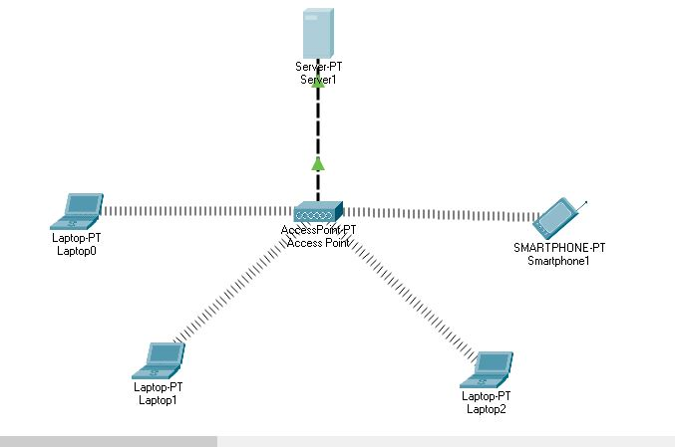

**Step 2:** Place Wireless Interface Card to Laptops instead of c Ethernet card.

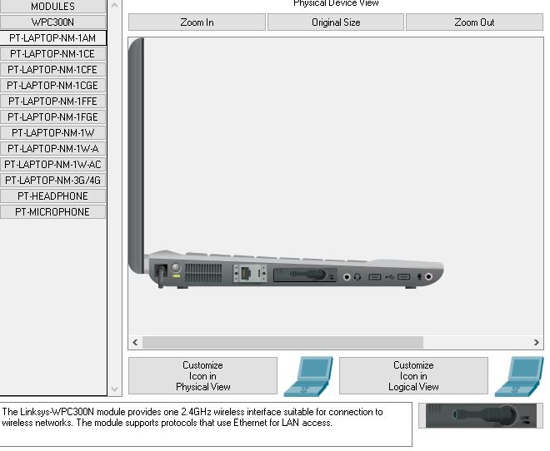

**Step 3: Assign Static IP to the server and also create an IP Pool.**

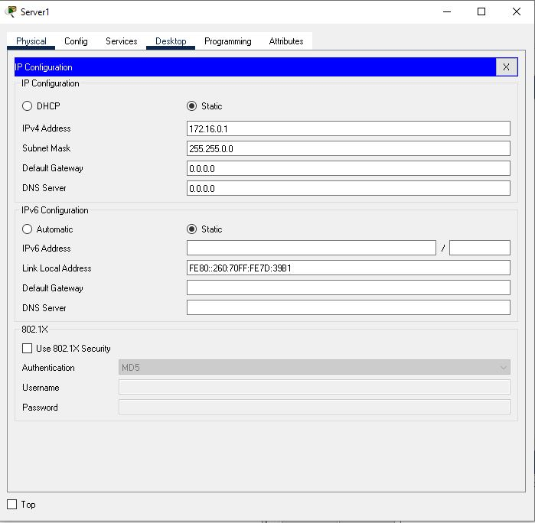

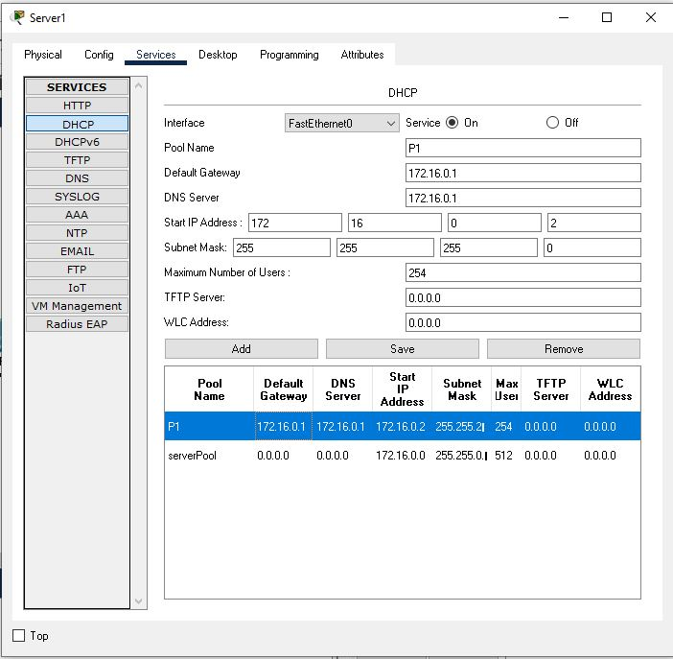

**Step 4: Check if DHCP is assigning IP’s to the Laptops.**

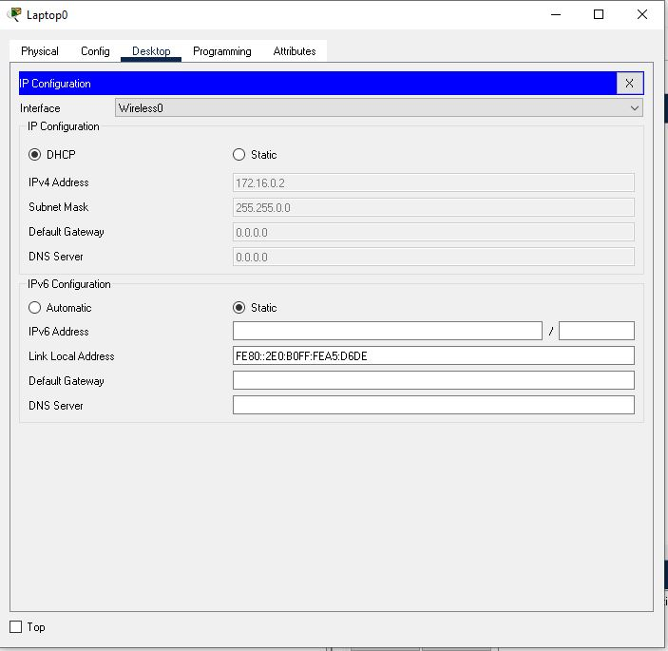

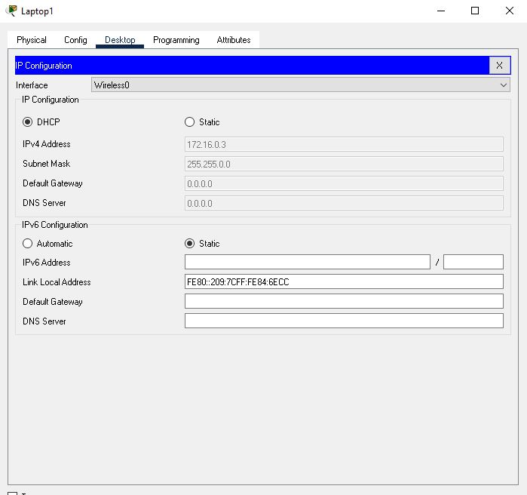

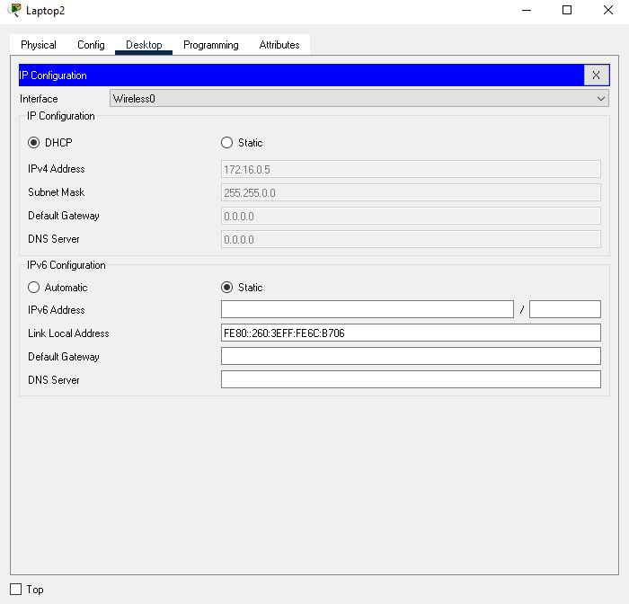

**Success!!!!!!!!!!!!!!!!!!!!!!!!!!!!!!!!!!!!!!!**

**Task 2: Wireless Router configuration in Cisco Packet Tracer**

**Solution:**

**Step 1: Topology**

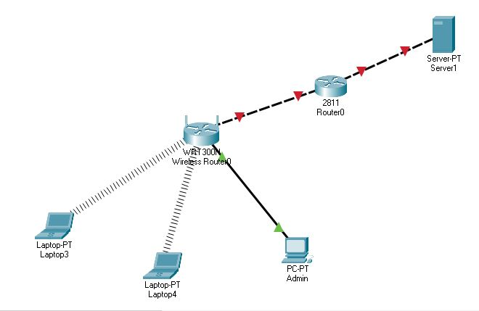

**Step 2:** We start with Administration in the GUI. Here we’ll simply change the router’s username and password and enabling IP Pool to Assign IP’s to the PC’s.

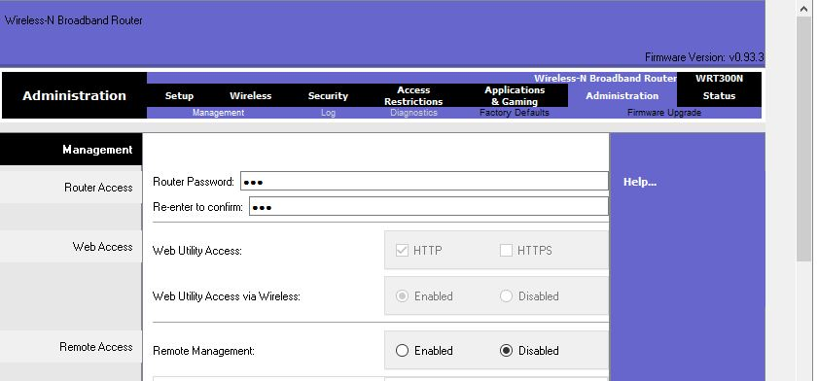

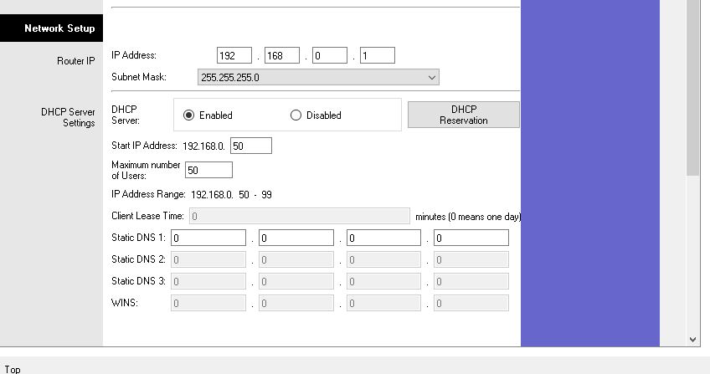

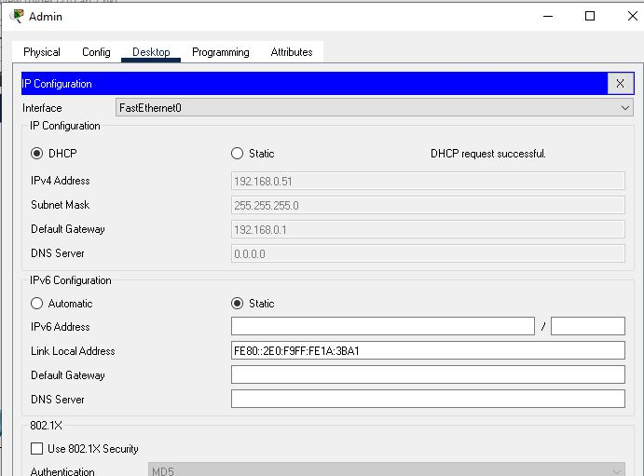

**Step 3:** Now we Add security for wireless LAN access.

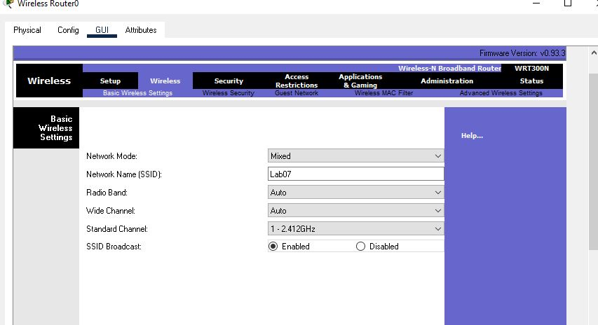

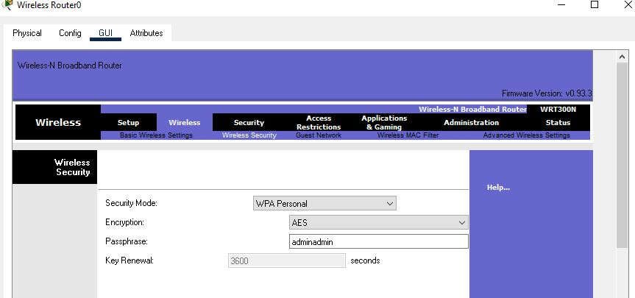

**Step 4: Now for reconnecting those PC’s use the following steps to connect to the router.**

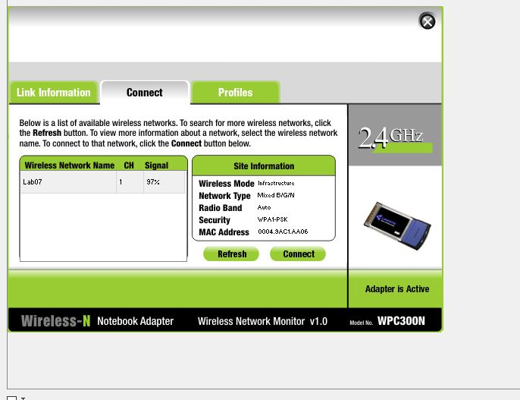

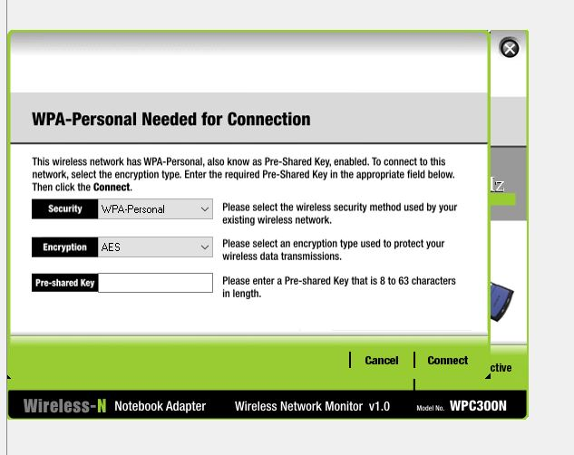

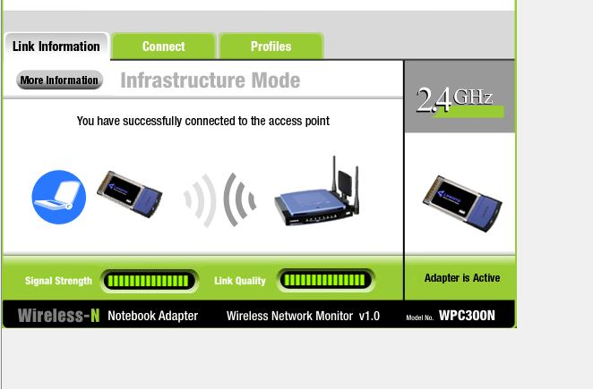

**Step 5: ISP router Configuration.**

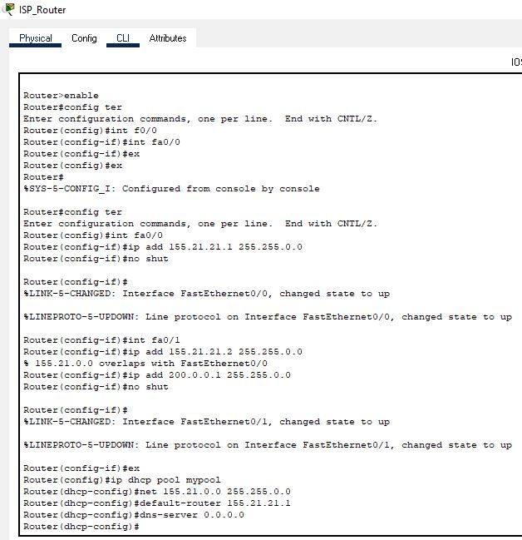

**Step 6: Now try Assigning IP’s to the PC’s using DHCP.**

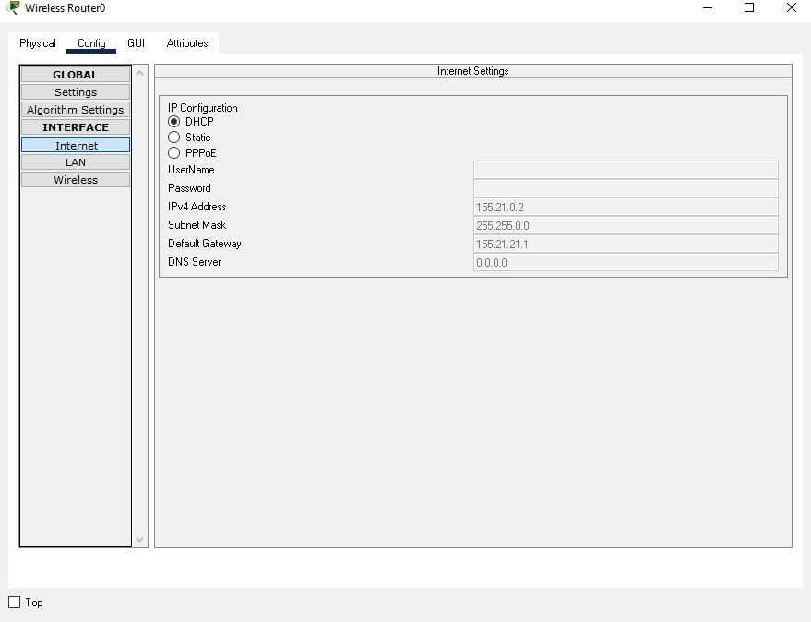

**Step 7: Try Ping command**

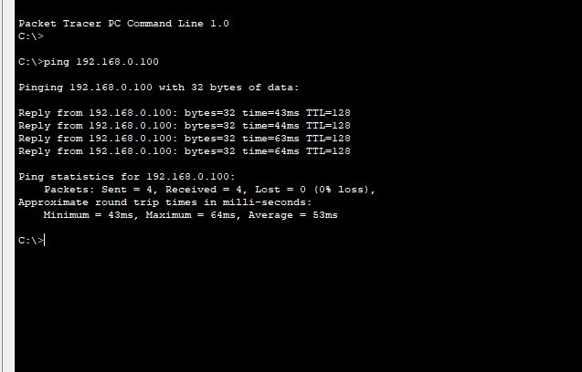

**Success!!!!!!!!!!!!!!!!!!!!!!!!!!!!!!!!!!**